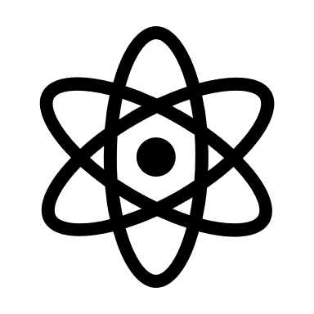
Eliminating Achievement Gaps

Honouring Truth, Reconciliation
and Rights

Leading in Community Research and Scholarship

On March 3rd, Dr. Emad Mohammed from the Engineering department presented his research on the design of a backend artificial intelligence software component to continuously and non-invasively pre-screen COVID-19 cough sounds using a mobile phone, hosted by Engineering & Geoscientists British Columbia.

Dr. Emad Mohammed has applied for a MITACS Accelerate program (20,000 – year-long “May 2022 to April 2023”) for the project, Design the Next Generation Recommendation System for Cancer Clinical Trials with industrial partner, Heal Mary, a Vancouver-based startup company.

Dr. Omer Waqar from Engineering has recently had a paper published in Transactions on Emerging Telecommunications Technologies (Wiley), Early Access, February 2022 titled “Federated learning and next generation wireless communications: A survey on bidirectional relationship”, with impact factor: 2.638.

Dr. Muhammed Hanif from the Engineering department has a newly published paper named “SSK-ICS LoRa: A LoRa-Based Modulation Scheme with Constant Envelope and Enhanced Data Rate” in the IEEE Communication Letters, February 2022.

Dr. Yasin Mamatjan has recently had two papers published in Neuro-Oncology. One of them is titled “Transcriptome and Methylome Analysis of CNS Germ Cell Tumor Finds its Cell-of-Origin in Embryogenesis and Reveals Shared Similarities with Testicular Counterparts”, February 2022. The other one is called “Methylation Based Prognostic Subtypes of Chordoma Tumors in Tissue and Plasma”, March 2022.

Designing Lifelong Learning

Strategic Initiatives, Outcomes
and Impacts

Key Deliverables, Activities and Achievements

Dr. Catherine Tatarniuk, Dr. Geoff Fink, and Kammi, with the support of Dr. Emad Mohammed, are putting together an interesting event titled “TRU Women in Engineering in the Engineering Dept.” on March 27th from 10am-3pm. This event aims to foster diverse, inclusive, and equitable learning and working environments attributable of the TRU strategic plan.

Awards or Accolades of Students,
Faculty and Employees

Dr. Emad Mohammed has managed to successfully secure TRU internal research funds (IRF) of 5,000 (March 2022 to March 2023). Dr. Yasin Mamatjan and Dr. Geoff Fink have also both acquired TRU IRF.

Funding has been received through the Research Accelerate Grant program for the project: “Development of a Novel Integrated Pan-Cancer Classification System to Improve Cancer Diagnosis as an Adjunct Tool to Pathology”.

